ITC LAB 8

**Lab Task. 8.1) Write a program that inputs, three numbers and find the greatest numbers among these numbers.**

#include <iostream>

using namespace std;

int main()

{

int a,b,c;

cout <<"Enter First number" << endl;

cin >>a;

cout <<"Enter Second number" <<endl;

cin >>b;

cout <<"Enter Third number" << endl;

cin >>c;

if ((a>b) && (a>c))

cout<<"The Greatest number is "<<a<< endl;

else if ((b>a) && (b>c))

cout<<"The Greatest number is "<<b<< endl;

else

cout<<"The Greatest number is "<<c<< endl;

return 0;

}

**Lab Task. 8.2) Write a program that swaps the value of two variables using a third variable**

#include <iostream>

using namespace std;

int main()

{

int a, b, c;

cout<<"enter 1st number; ";

cin>>a;

cout<<"Enter 2nd Number: ";

cin>>b;

cout<<"Before Swapping"<<endl;

cout<<"First Number "<<a<<endl;

cout<<"Second number "<<b<<endl;

c=a;

a=b;

b=c;

cout<<"After Swapping"<<endl;

cout<<"First Number "<<a<<endl;

cout<<"Second number "<<b<<endl;

return 0;

}

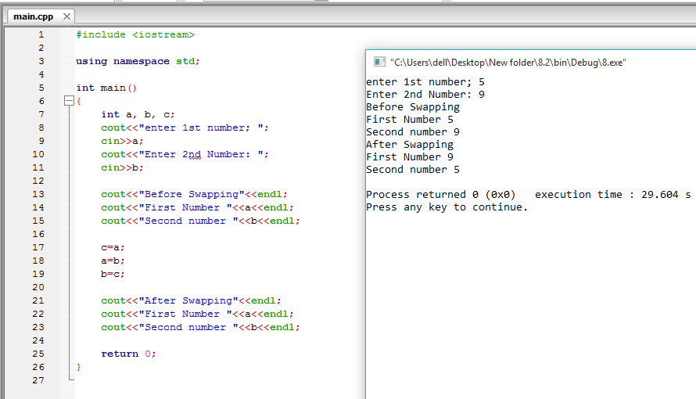

**Lab Task. 8.3) Write a program that checks whether the entered year is a leap year or not**

#include <iostream>

using namespace std;

int main()

{

int a;

cout<<:enter a year” << endl ;

cin>>a;

if((a%4==0))

cout <<a<<”is a leap year”<<endl;

else

cout<<a<<”a is not a leap year”<<endl;

return 0

}

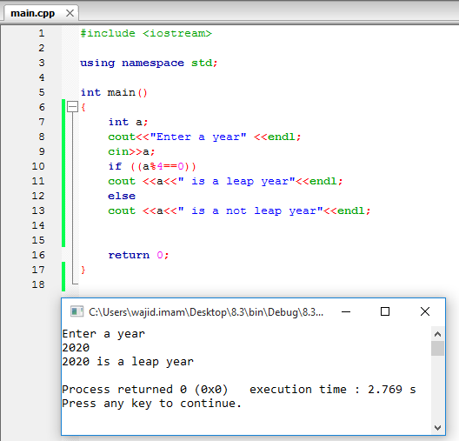

**Lab Task. 8.4) Write a program that checks whether the entered number is positive or negative.**

#include <iostream>

using namespace std;

int main()

{

int a;

cout<<"Enter a Number" <<endl;

cin>>a;

if ((a>=0))

cout <<a<<" is a positive number"<<endl;

else

cout <<a<<" is a negative number"<<endl;

return 0;

